Main and Bill-TO

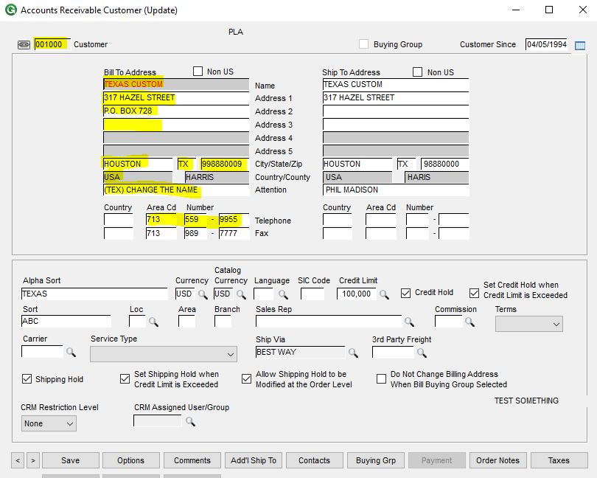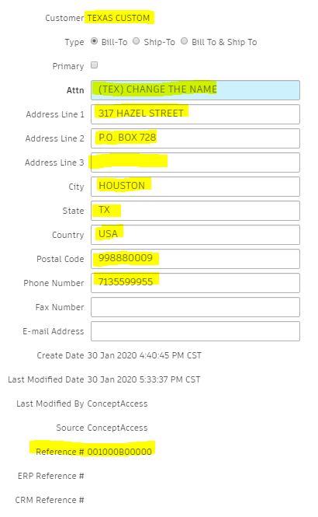

Primary Ship-to and Additional Ship-to

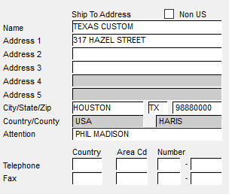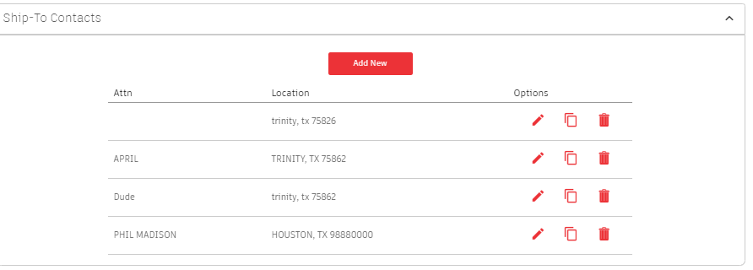

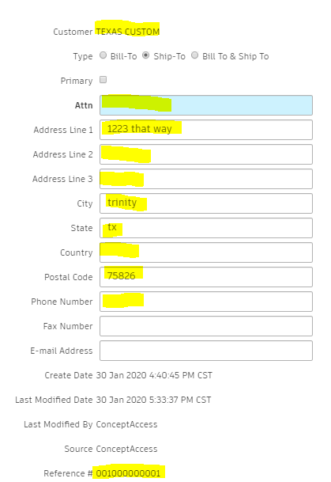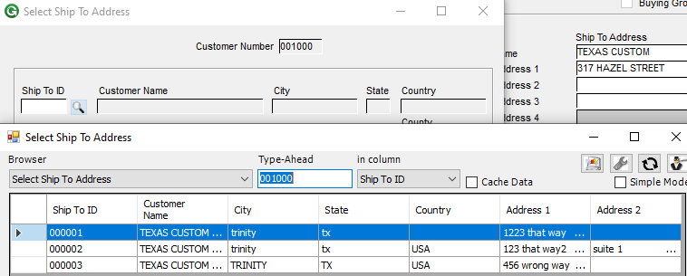

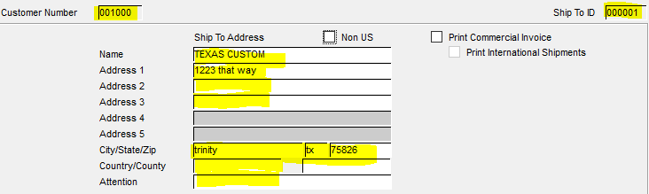

User Defined Mapping (TBD)

Need Maintainer personnel to define this so it can be coded only once due to the logic that is involved. This will prevent us from going over budget on hours.

If they want the same ones 1-10, then we can do that easily, but GSS has more so I wanted to let Maintainer make this decision.

If they want different fields from customer master sent over, that is fine as well.

